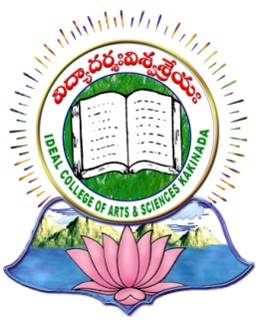 | IDEAL COLLEGE OF ARTS AND SCIENCES (A)
 | (A.P. Govt., Aided., Autonomous & NAAC B++)
 | Dr. P.V.N. RAJU VIDYAPRANGANAM
Samalkot Road, KAKINADA
East Godavari Dist
Andhra Pradesh

Department of English

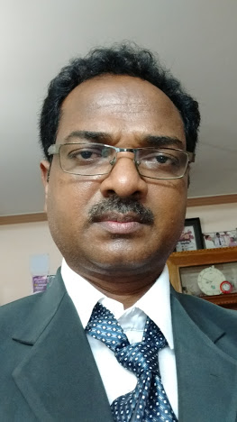

PROFILE

- Name : M. Soma Raju
- Designation and Place of work : Sr. Lecturer in English
Ideal College of Arts & Sciences (A)
Kakinada-533003
A.P., INDIA.
- Date of Birth : 24-04-1969
- Nationality : Indian
- Mobile no : 8008888485
- E-mail : somaraju8485@gnail.com
- Address for Correspondence : M. Soma Raju
Sr Lecturer in English Ideal College of Arts & Sciences,
Kakinada – 533 004, A.P., India.

- Details of Educational Qualifications:
Sl. No. | Course | University | Year | Specialization
1 | M.A | Andhra university | 1994 | Romantics.
2 | Ph.D | Andhra university | Thesis submitted on 13th july 2013 | Philip Larkin’s Poetry-A Study.

- Experience:

Sl.No | Designation | College | Date of Joining | Experience
1 | J.L &D.L | S V Jr. College & Govt. Degree College | 16-10-1995 | 07Years
2 | Sr. Lecturer | SKBR College, Amalapuram | 06-06-2002 | 12 Years
3 | Sr. Lecturer | Ideal college of arts and sciences | 09-10-2014 | 03 Years

- Regional/ State/National level Conferences/Workshops/Seminars

International journal-06
Seminars-16

- Administrative Experience:
Admissions, discipline committees

- Training Programs/ Courses attended: 04/05

